Supplemental figures
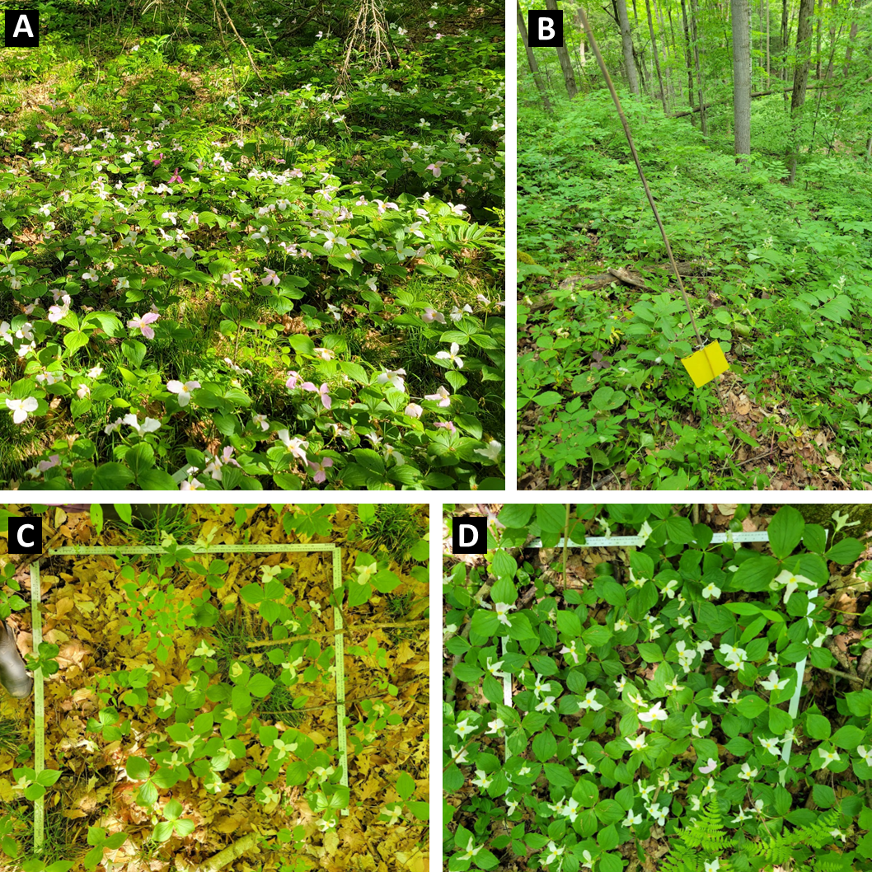
Figure S1. White trillium at the Koffler Scientific Reserve and methods used to sample. White trillium is a common spring ephemeral at the field station (A). We placed sticky traps for trapping and sequencing leafhopper vectors (B). We sampled 1 m² plots of varying trillium density (C, D). Photos taken by Julia Boyle in 2023.
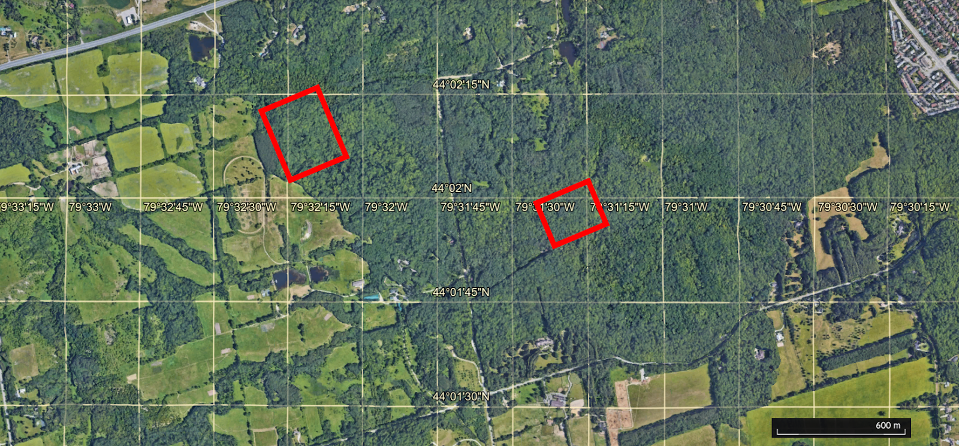
Figure S2. General sampling areas of white trillium at the Koffler Scientific Reserve are indicated within the red rectangles. Marked grid lines display latitude and longitude, and a scale bar is in the lower right-hand corner.

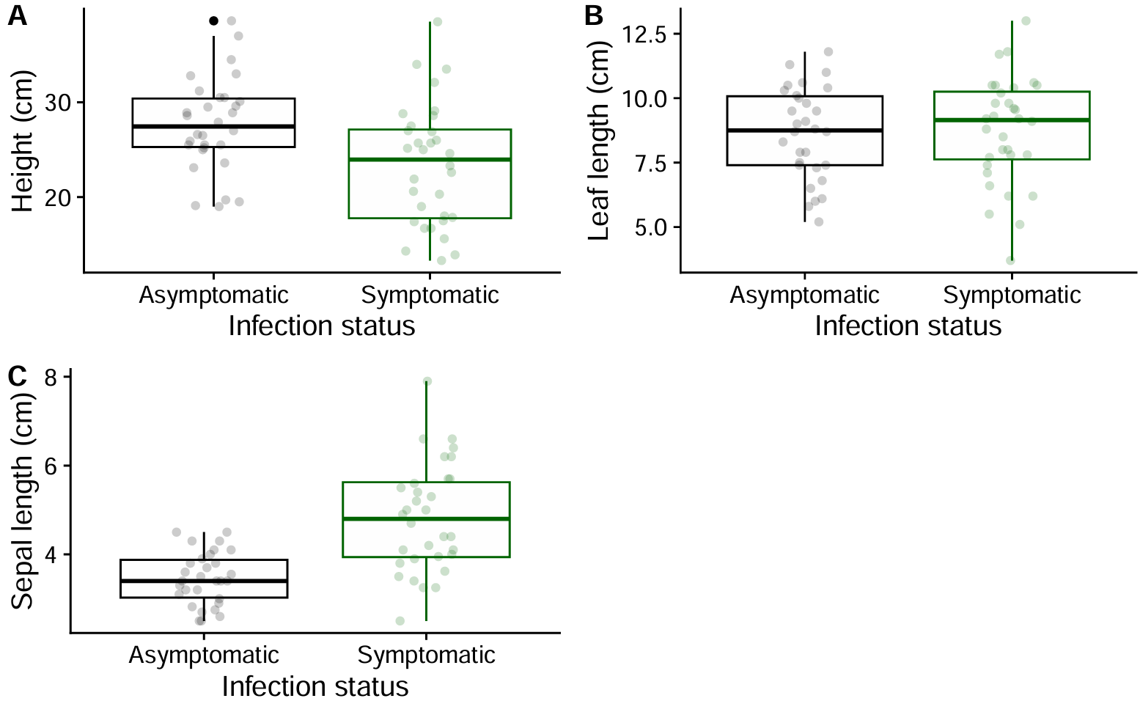
Figure S3. Phenotypic traits of T. grandiflorum are altered when infected with phytoplasma. Height was significantly reduced and sepal length was significantly increased in infected individuals. Leaf length was not significantly different. Data from 2023 surveys (asymptomatic n = 30, symptomatic n = 32).

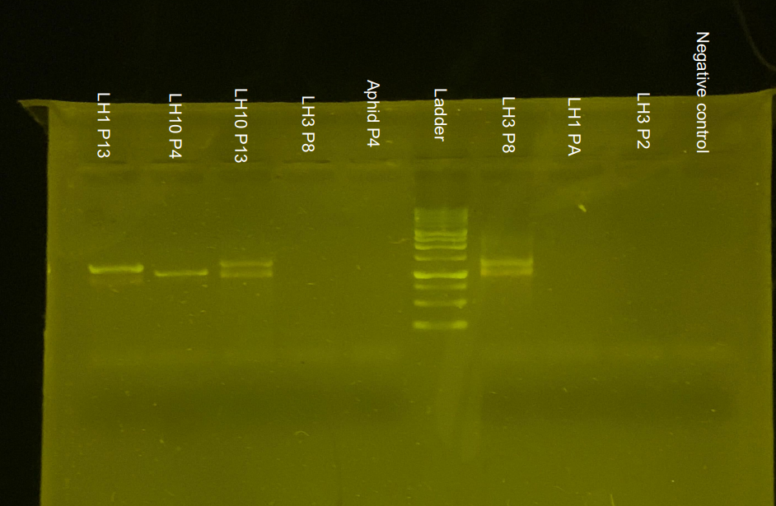
Figure S4. Subset of tested insect samples, containing all positive samples. LH = Leaf hopper. The number after LH is the morphotype; we determined morphotypes 1 and 3 were the same after data collection. P# denotes the plot the insect was collected from (all insects also have unique individual numbers, not included here for brevity). There appears to be two bands amplified for phytoplasma.

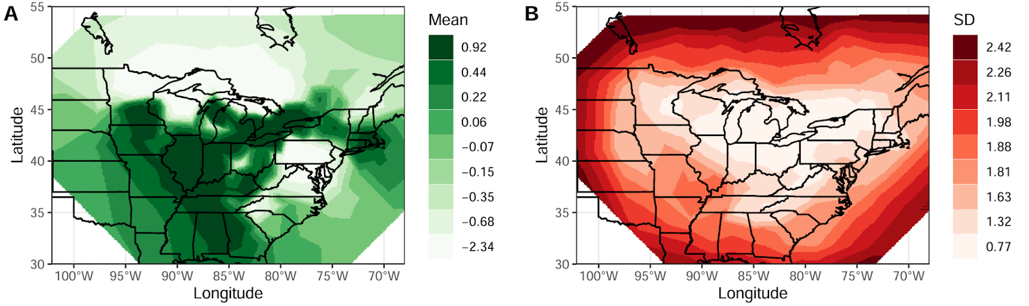
Figure S5. Spatial field mean (A) and standard deviation (B), estimated from the INLA model. Spatial fields represent marginal posterior effects of the random effects of space. Values are shown across the mesh.

Table S1. Phenotypic response of trillium to phytoplasma infection. Data from 2023 surveys (asymptomatic n = 30, symptomatic n = 32). Estimates are relative to asymptomatic plants.
 | Height (cm) |  |  |  | Leaf length (cm) |  |  |  | Log of Sepal length (cm)
Predictor | Estimate | Std. Error | Wald Chisq | p | Estimate | Std. Error | Wald Chisq | p | Estimate | Std. Error | Wald Chisq | p
Intercept | 27.8 | 1.12 | 611 | < 0.001 | 9.09 | 0.525 | 300 | < 0.001 | 1.30 | 0.063 | 430 | < 0.001
Infection status | -4.39 | 1.48 | 8.77 | 0.003 | -0.342 | 0.488 | 0.491 | 0.484 | 0.282 | 0.056 | 25.6 | < 0.001

Table S2. Phytoplasma reduced white trillium fitness more than expected based on trillium size and location. Infection status estimates are relative to asymptomatic plants, and modeled seed count status is relative to predicted seed counts. Boxes are greyed if not relevant to the model under ‘model goal’.
Response | Seed count
Model goal | Do infected trillium make fewer seeds than predicted based on their size? |  |  |  | Do infected trillium make fewer seeds than a nearby asymptomatic trillium?
Predictor | Estimate | Std. Error | Wald Chisq | p | Estimate | Std. Error | Wald Chisq | p
Intercept | 2.77 | 0.119 | 541 | < 0.001 | 2.91 | 0.116 | 635 | < 0.001
Modeled seed count status | -1.21 | 0.216 | 31.3 | < 0.001
Infection status |  |  |  |  | -1.24 | 0.210 | 34.7 | < 0.001

Table S3. Zero-inflated model for the population dynamics of the multiyear dataset (2018 and 2023). This model included random effects of sub-population at the Koffler Scientific Reserve. Plots were 1 m².
 | Infected trillium presence (zero model) |  |  |  | Infected trillium no. (count model)
Predictor | Estimate | Std. Error | z-value | p | Estimate | Std. Error | z-value | p
Intercept | -0.434 | 0.880 | -0.494 | 0.621 | -0.139 | 0.226 | -0.613 | 0.540
Reproductive trillium no. | 0.064 | 0.025 | 2.56 | 0.010 | 0.016 | 0.009 | 1.81 | 0.069
Year | -3.17 | 1.54 | -2.07 | 0.039 | 0.085 | 0.226 | 0.377 | 0.706

Table S4. Zero-inflated model for the population dynamics of the 2023 dataset. This model excluded random effects of sub-population at the Koffler Scientific Reserve. Plots were 1 m².
 | Infected trillium presence (zero model) |  |  |  | Infected trillium no. (count model)
Predictor | Estimate | Std. Error | z-value | p | Estimate | Std. Error | z-value | p
Intercept | -10.1 | 8.43 | -1.20 | 0.231 | -2.29 | 1.38 | -1.66 | 0.097
Reproductive trillium no. | 0.099 | 0.044 | 2.22 | 0.026 | 0.014 | 0.012 | 1.11 | 0.267
Proportion of reproductive trillium with Hemiptera nymphs | 6.43 | 7.71 | 0.834 | 0.404 | 2.51 | 1.35 | 1.86 | 0.063

Table S5. Binomial generalised linear models testing whether trillium density predicts Hemiptera prevalence (A), and whether Hemiptera prevalence predicts infection proportions (B).

Predictor | Estimate | Std. Error | z-value | p
- Proportion of trillium that had Hemiptera on them ~ number of trillium in a plot
Intercept | 1.57 | 0.080 | 19.77 | <0.001
Number of trillium | -0.00883 | 0.000819 | -10.78 | <0.001
- Proportion of adult trillium with symptoms of infection ~ proportion of adult trillium in a plot with Hemiptera
Intercept | -6.82 | 0.780 | -8.74 | <0.001
Proportion with Hemiptera | 3.95 | 0.850 | 4.65 | <0.001

Table S6. Number of Hemiptera morphotypes caught and tested, and their phytoplasma positivity rate. Phytoplasma infection was determined with a nested polymerase chain reaction using two universal phytoplasma primer pairs R16mF2/R1 and R16F2n/R2 (Gundersen & Lee 1996), and we visualised the presence of phytoplasma using gel electrophoresis. We determined leafhopper morphotypes 1 and 3 were likely the same species by morphology, but differing in sample freshness/time since mortality.
Morphotype | Number caught | Number tested | Number positive | Percent positive %
Leafhopper 1+3 | 279+223 | 48+20 | 1+1 | 2.94
Leafhopper 2 | 154 | 7 | 0 | 0
Leafhopper 4 | 16 | 1 | 0 | 0
Leafhopper 5 | 6 | 2 | 0 | 0
Leafhopper 6 | 2 | 1 | 0 | 0
Leafhopper 7 | 6 | 0 | NA | NA
Leafhopper 8 | 18 | 4 | 0 | 0
Leafhopper 9 | 16 | 2 | 0 | 0
Leafhopper 10 | 58 | 5 | 2 | 40
Leafhopper 11 | 9 | 0 | NA | NA
Leafhopper 12 | 4 | 1 | 0 | 0
Leafhopper 13 | 6 | 0 | NA | NA
Leafhopper 14 | 1 | 0 | NA | NA
Leafhopper 15 | 6 | 0 | NA | NA
Leafhopper nymph 1 | 3 | 1 | 0 | 0
Leafhopper nymph 2 | 3 | 3 | 0 | 0
Leafhopper nymph 3 | 1 | 1 | 0 | 0
Treehopper 1 | 2 | 0 | NA | NA
Treehopper 2 | 2 | 0 | NA | NA
Psyllid 1 | 11 | 9 | 0 | 0
Psyllid 2 | 1 | 0 | NA | NA
Aphid 1 (Black colour) | 49 | 3 | 0 | 0
Aphid 2 (Long legs) | 2 | 0 | NA | NA
Aleyrodidae/whiteflies | 28 | 0 | NA | NA
TOTAL | 906 | 110 | 4 | 3.64

Table S7. Posterior summaries of the integrated nested Laplace approximation (INLA) model results with stochastic partial differential equation random effects to account for spatial autocorrelation. The deviance information criterion (DIC) was 4380.14, saturated DIC was 4339.16.
Fixed effects | Mean | Standard deviation | 0.025 quantile | 0.5 quantile | 0.975 quantile | Mode
Intercept | 9.84 | 3.67 | 2.71 | 9.81 | 17.1 | 9.81
Trillium no. in 5 km² grid | 0.00 | 0.00 | -0.001 | 0.00 | 0.001 | 0.000
Mean diurnal range | 0.057 | 0.142 | -0.223 | 0.057 | 0.334 | 0.057
Min. temp. of coldest month | 0.191 | 0.103 | -0.016 | 0.192 | 0.391 | 0.192
Mean temp. of wettest quart. | -0.023 | 0.017 | -0.057 | -0.023 | 0.010 | -0.023
Mean temp. of driest quart. | -0.044 | 0.037 | -0.118 | -0.044 | 0.029 | -0.044
Mean temp of warmest quart. | -0.644 | 0.151 | -0.944 | -0.642 | -0.352 | -0.642
Precip. of driest month | -0.014 | 0.012 | -0.037 | -0.013 | 0.009 | -0.013
Cropland cover | 0.686 | 0.304 | 0.090 | 0.686 | 1.28 | 0.686
Footprint | -0.006 | 0.005 | -0.017 | -0.006 | 0.004 | -0.006
Random effects
Range for spatial effects | 4.96 | 1.90 | 2.38 | 4.60 | 9.73 | 3.93
St. dev. for spatial effects | 1.90 | 0.435 | 1.22 | 1.84 | 2.92 | 1.72

Table S8. Posterior summaries of the base integrated nested Laplace approximation (INLA) model results (no stochastic partial differential equation). The deviance information criterion (DIC) was 4705.98, and the saturated DIC was 4664.99.
Fixed effects | Mean | Standard deviation | 0.025 quantile | 0.5 quantile | 0.975 quantile | Mode
Intercept | 16.8 | 1.34 | 14.2 | 16.8 | 19.4 | 16.8
Trillium no. in 5 km² grid | 0.000 | 0.000 | 0.000 | 0.000 | 0.001 | 0.00
Mean diurnal range | -0.466 | 0.057 | -0.578 | -0.466 | -0.354 | -0.466
Min. temp. of coldest month | 0.242 | 0.032 | 0.179 | 0.242 | 0.305 | 0.242
Mean temp. of wettest quart. | -0.002 | 0.011 | -0.024 | -0.002 | 0.020 | -0.002
Mean temp. of driest quart. | -0.068 | 0.027 | -0.122 | -0.068 | -0.015 | -0.068
Mean temp of warmest quart. | -0.672 | 0.063 | -0.795 | -0.672 | -0.549 | -0.672
Precip. of driest month | -0.016 | 0.004 | -0.025 | -0.016 | -0.007 | -0.016
Cropland cover | 1.70 | 0.269 | 1.171 | 1.70 | 2.23 | 1.70
Footprint | 0.010 | 0.004 | 0.002 | 0.010 | 0.019 | 0.010

